
ARANEA DEN | COMPANY PROFILE | 2026
brings strategy, design, and technology together to create digital experiences that connect brands with people. We build websites, brand identities, digital products, and marketing experiences with a clear focus on purpose, creativity, and impact.
Great digital experiences are never made from isolated pieces. Strategy shapes the direction. Design creates the connection. Technology brings it to life.
IDENTITY
Identity is rooted in the idea of connection; the web represents how we bring different disciplines together to create complete digital experiences. From brand and web to apps, content, campaigns, and technology, we connect every element with purpose. WE WEAVE DIGITAL EXPERIENCES.
We combine creative thinking, strategic direction, and technical execution to build digital experiences that are distinctive, cohesive, and built for growth. Our symbol reflects this philosophy — a web of connected ideas, capabilities, and possibilities.
VISION
To become a leading digital studio where strategy, creativity, and technology come together to shape meaningful digital experiences, build distinctive brands, and create lasting impact for businesses and their audiences.
MISSION
To transform ideas and business objectives into meaningful digital experiences by bringing together strategy, design, technology, content, and growth to create solutions that connect, engage, and deliver lasting value.
SERVICES
- Web Development / Website Development — building fast, scalable websites and web platforms.
- Mobile App Development — iOS and Android application development.
- UI/UX Design — designing intuitive and engaging digital interfaces and experiences.
- Digital Marketing — strategy, content, performance and growth-oriented marketing.
- Video Production — cinematic and engaging video storytelling.
- Graphic Design — visual identity, communication and brand design.
- SEO Services / SEO Optimization — improving search visibility and organic performance.
- Cloud Solutions — scalable and secure cloud infrastructure.

TARGET CUSTOMERS
- Startups and emerging brands.
- Growing businesses seeking stronger digital presence.
- Organizations requiring websites or digital platforms.
- Brands requiring identity and visual communication.
- Organizations seeking mobile applications.
- Businesses seeking digital marketing and SEO support.
- Clients requiring broader connected digital ecosystems.

LEARDERSHIP
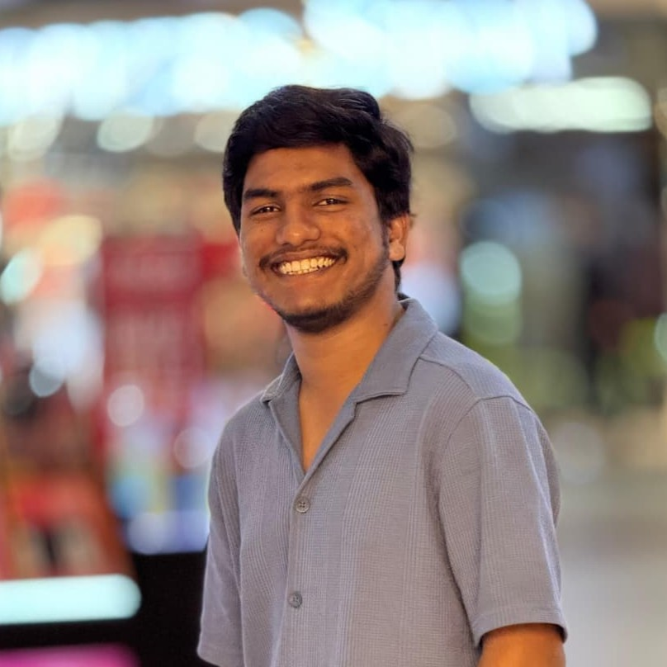
Saikiran Chapa
Founder & CEO
Saikiran Chapa leads Aranea Den with a vision to build a forward-thinking digital studio where strategy, creativity, and technology work together to create meaningful digital experiences.
With a focus on innovation and connected thinking, he drives the studio’s direction across digital strategy, brand development, design, technology, and digital experiences. His approach brings together creative ideas and practical technology to help businesses build stronger, more distinctive digital identities.
Under his leadership, Aranea Den is shaped around the belief that every digital experience should have purpose, clarity, and a meaningful connection with its audience.

THE POWERHOUSE
Sai Kiran Chapa
Founder & CEO
Leads Aranea Den with a vision to unite strategy, creativity, and technology to create meaningful digital experiences and build distinctive brands.
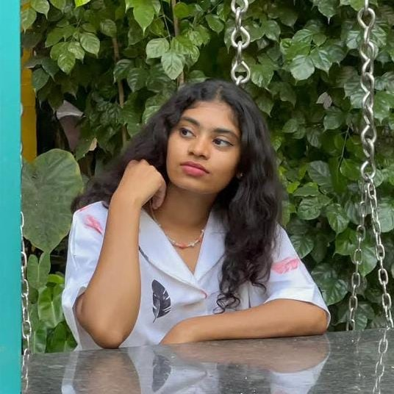
Angle
Graphic Designer & Video Editor
Creates visually compelling designs and engaging video content that bring Aranea Den’s creative vision and brand identity to life.


Shiva
Video Editor
Crafts engaging video content and compelling visual narratives that bring Aranea Den’s creative ideas to life.
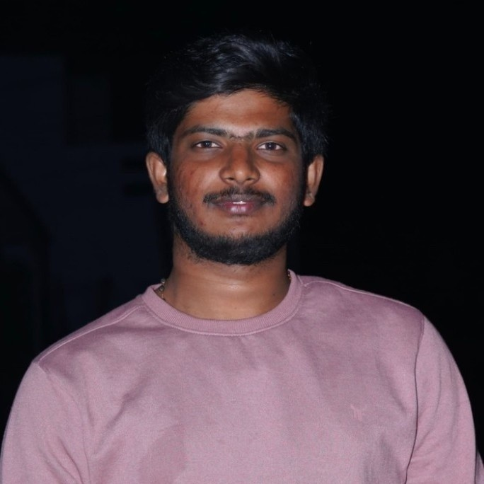
Chandu
Visuals
Captures compelling visuals and cinematic footage that bring Aranea Den’s creative vision and brand stories to life.
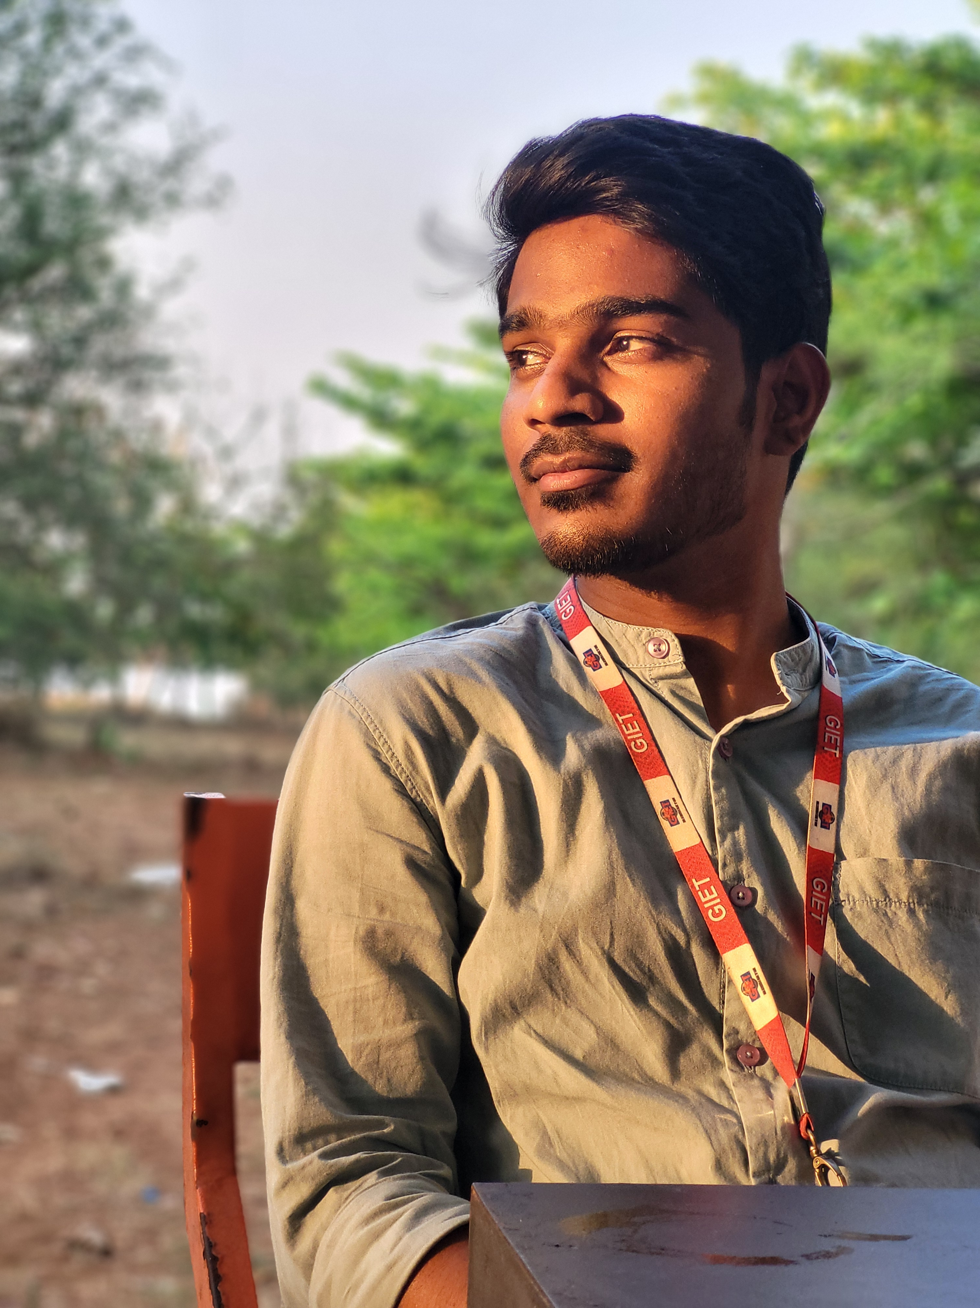
Surya
Web & App Developer
Builds responsive websites and intuitive applications that transform ideas into seamless, engaging digital experiences.
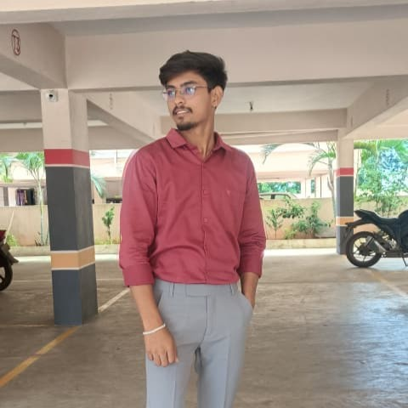
John
FS Developer
Develops seamless web applications by combining intuitive front-end experiences with robust back-end functionality, bringing ideas to life through technology.

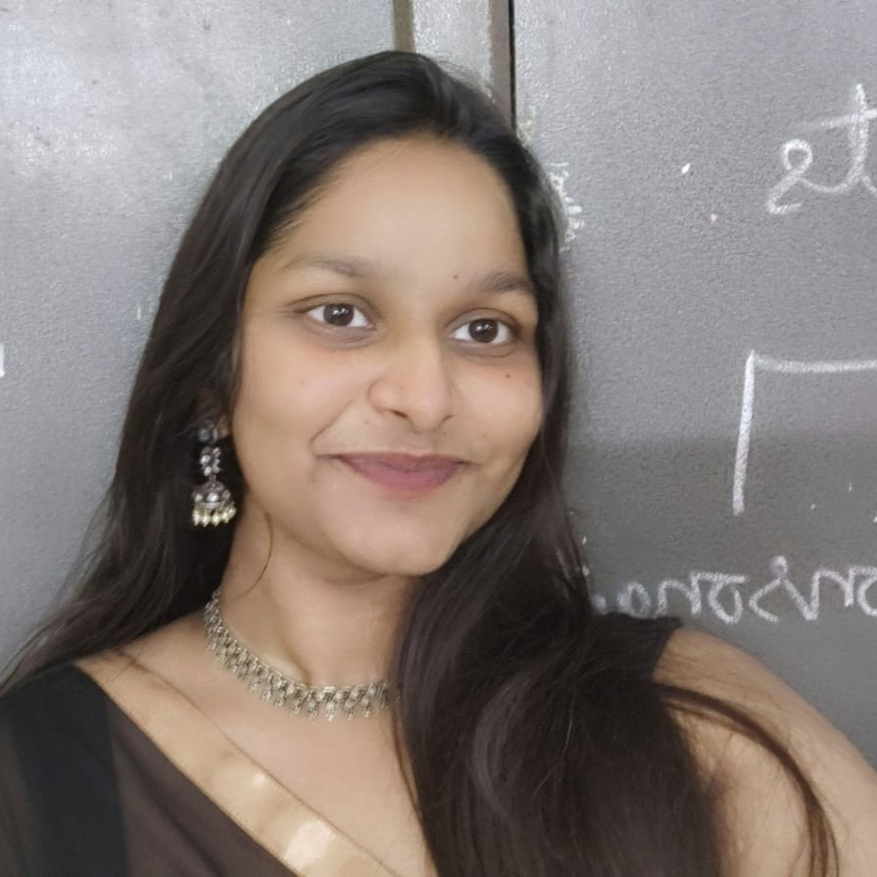
Jagruthi
FS Developer
Builds dynamic web applications by combining intuitive user interfaces with reliable back-end systems to deliver seamless digital experiences.
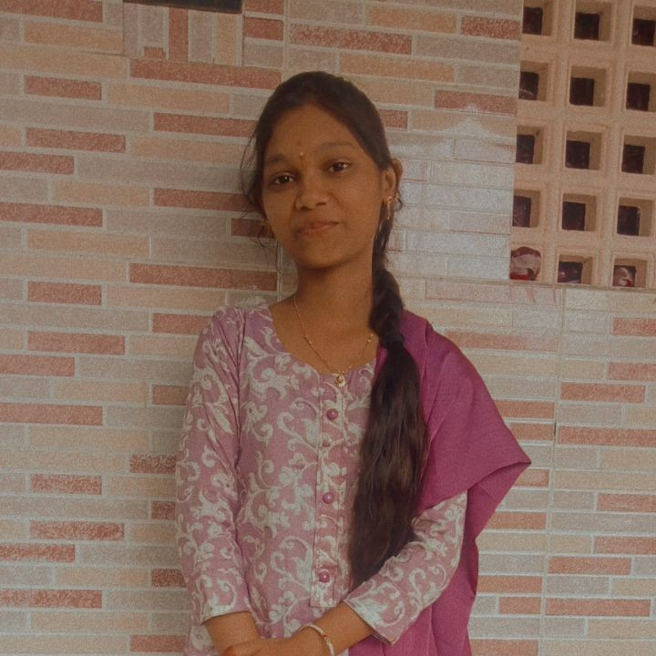
Pujitha
Social Media Manager
Manages Aranea Den’s social media presence, crafting engaging content and building meaningful connections with audiences across digital platforms.

- Sai Kiran Chapa – Founder & CEO
- Angle – Graphic Designer & Video Editor
- Shiva – Video Editor
- Chandu - Videography
- Surya – Web & App Developer
- John – FS Developer
- Jagruthi - FS Developer
- Pujitha M - Social Media Manager

